

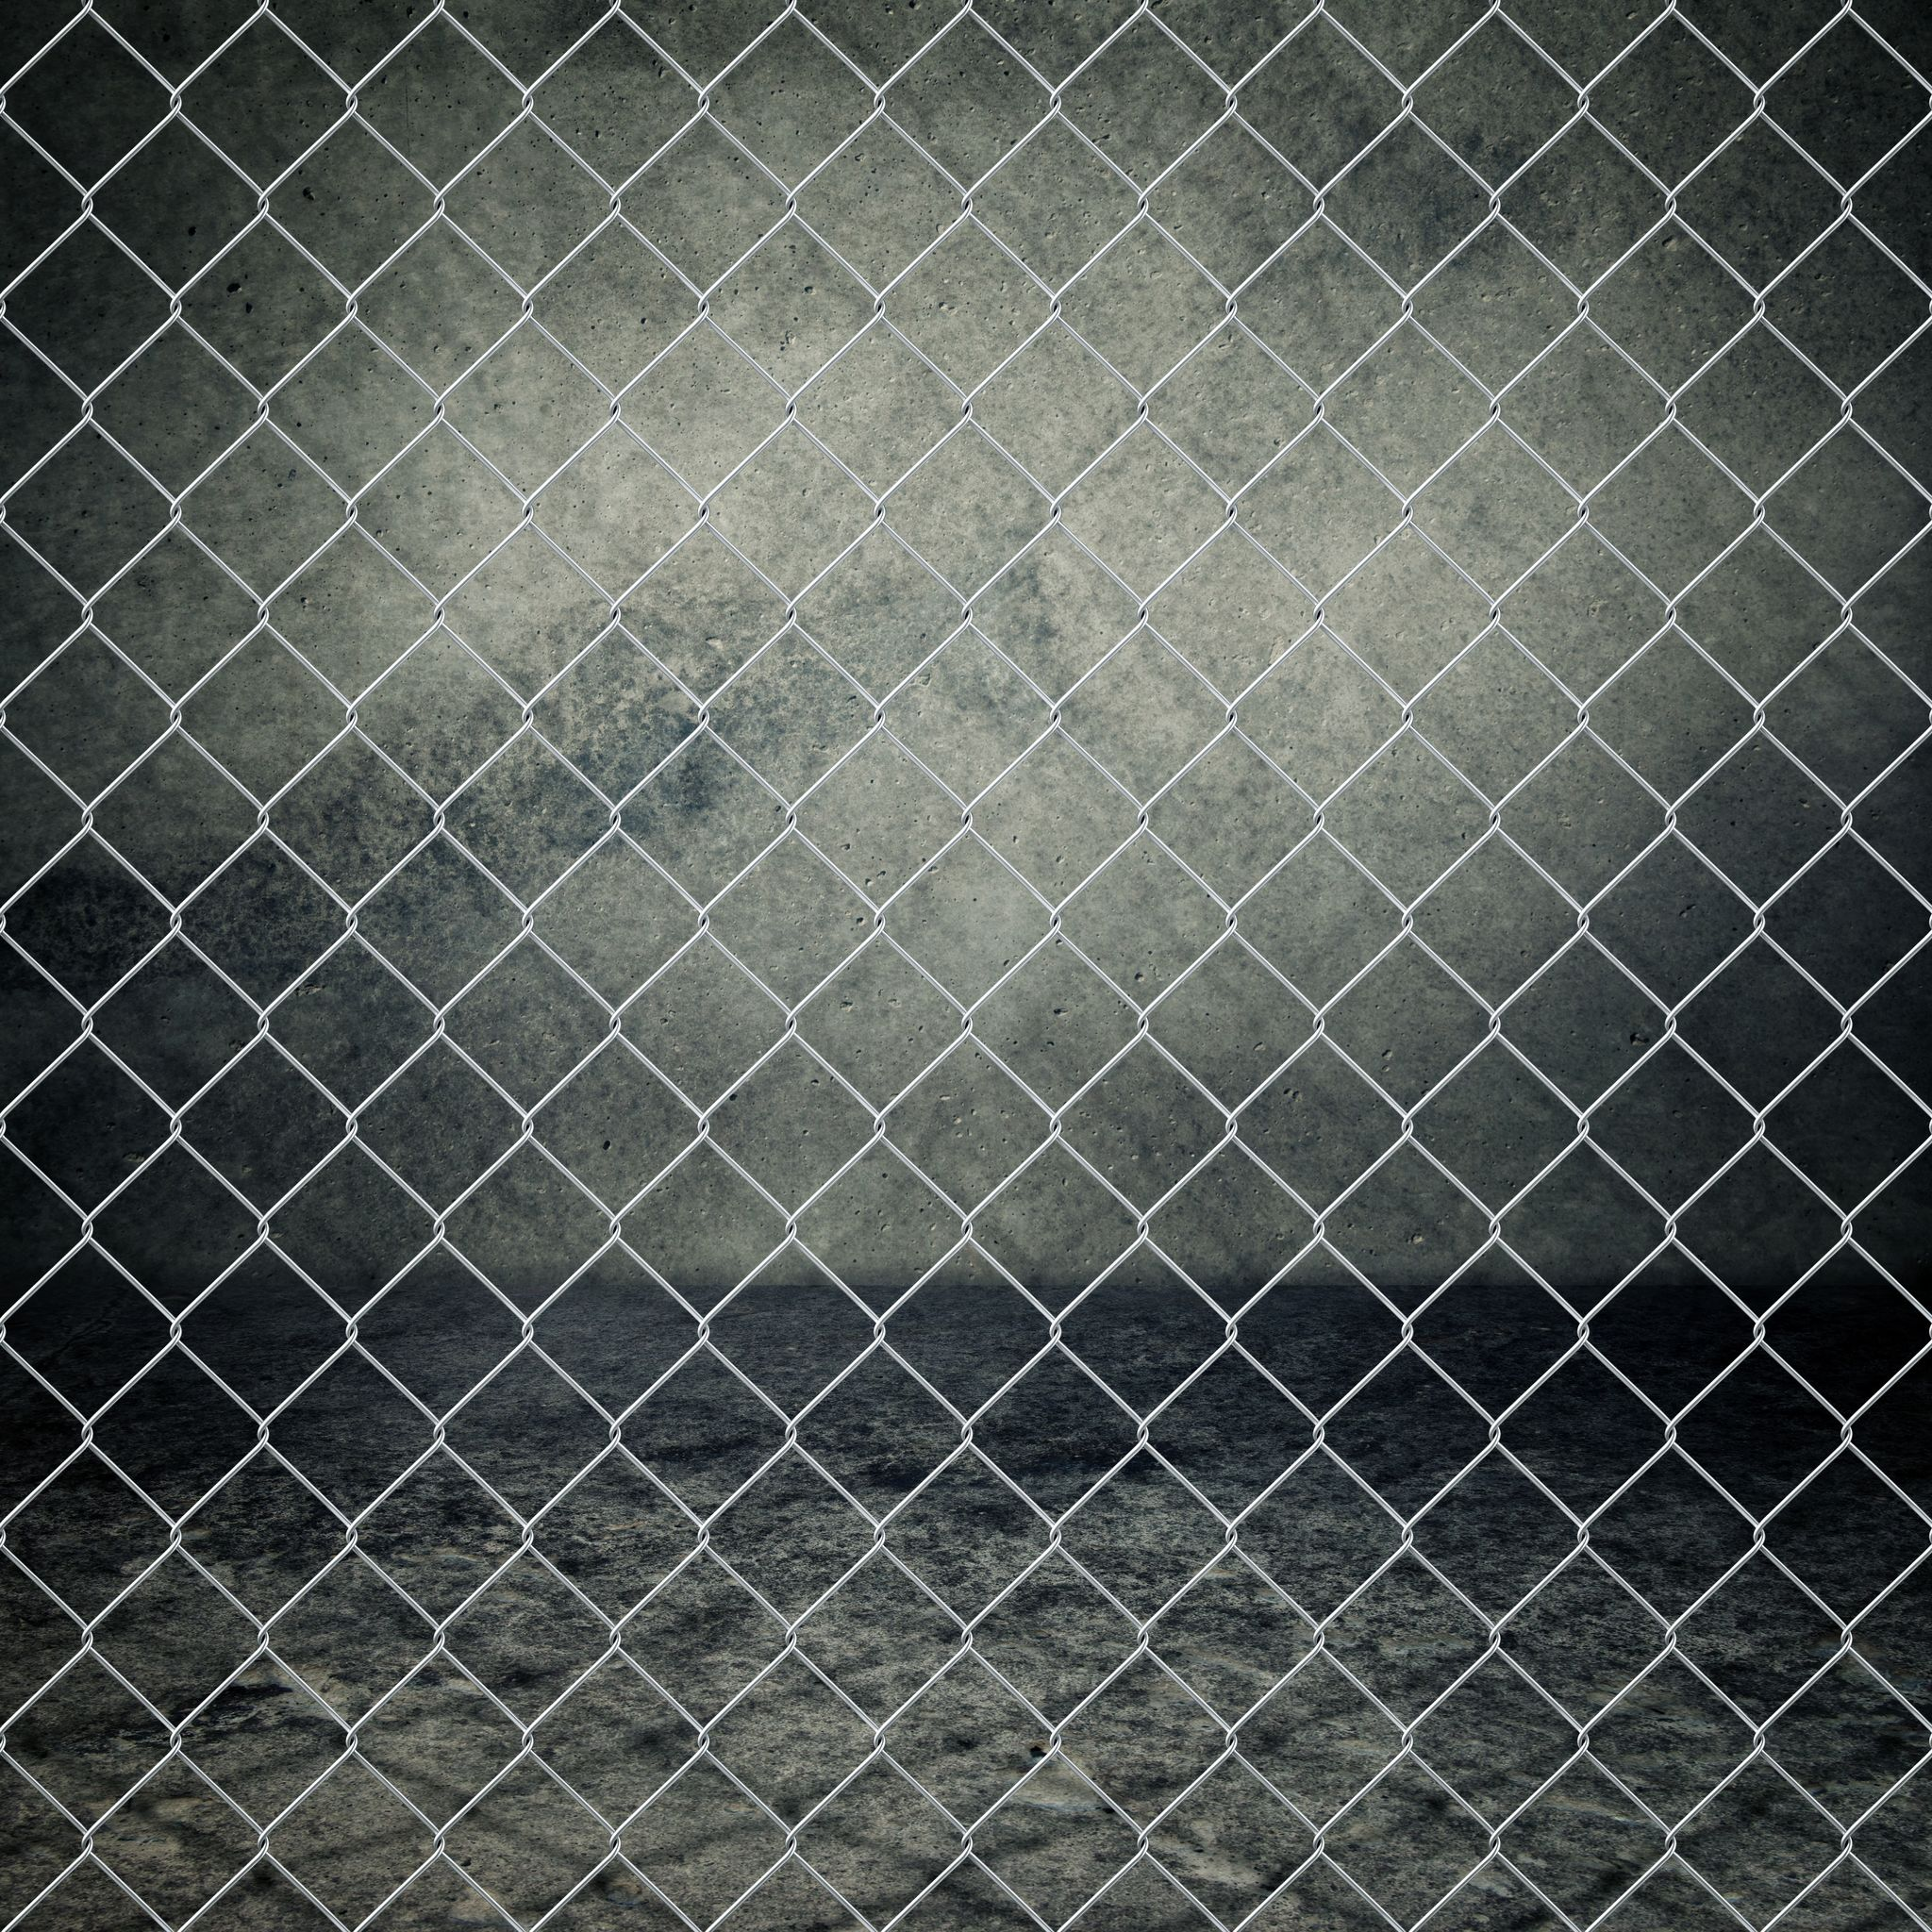

[https://image.jimcdn.com/app/cms/image/transf/dimension=290x1024:format=jpg/path/s2a6052df1d35246c/image/i09d2afbb5fba8da7/version/1437308821/image.jpg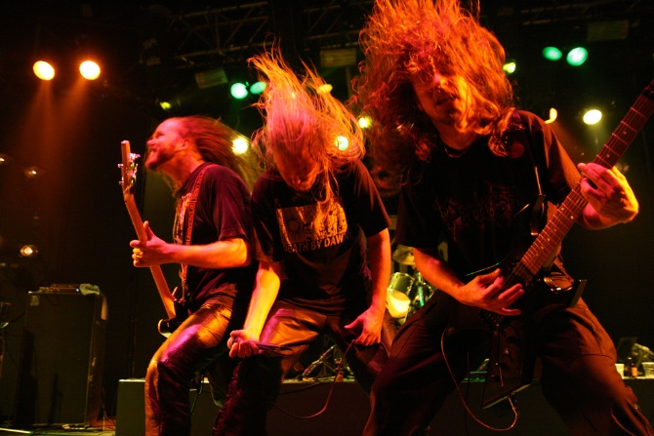](https://image.jimcdn.com/app/cms/image/transf/dimension=290x1024:format=jpg/path/s2a6052df1d35246c/image/i09d2afbb5fba8da7/version/1437308821/image.jpg)

<https://goo.gl/images/Ei4VaG>

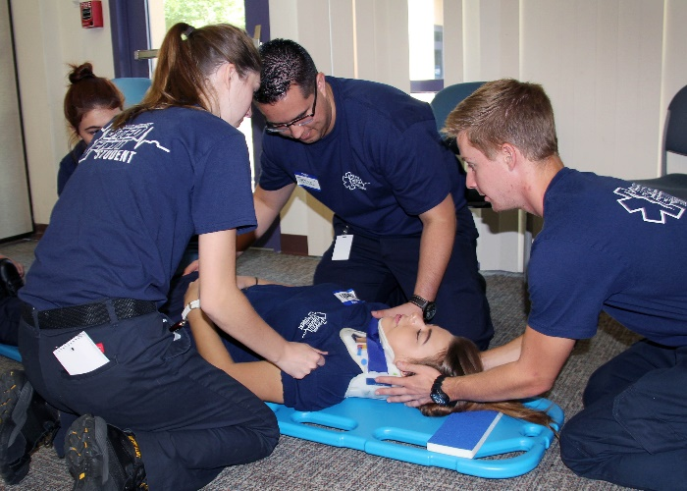

<https://www.google.com/url?sa=i&rct=j&q=&esrc=s&source=images&cd=&cad=rja&uact=8&ved=2ahUKEwjr48O_8YTfAhWH1FkKHcy0A0IQjRx6BAgBEAU&url=https%3A%2F%2Fwww.topsimages.com%2Fimages%2Femt-man-25.html&psig=AOvVaw2oKFs941FF4neBHS0XJnfJ&ust=1543968628041169>

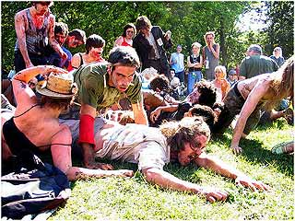

<https://goo.gl/images/jv42bV>

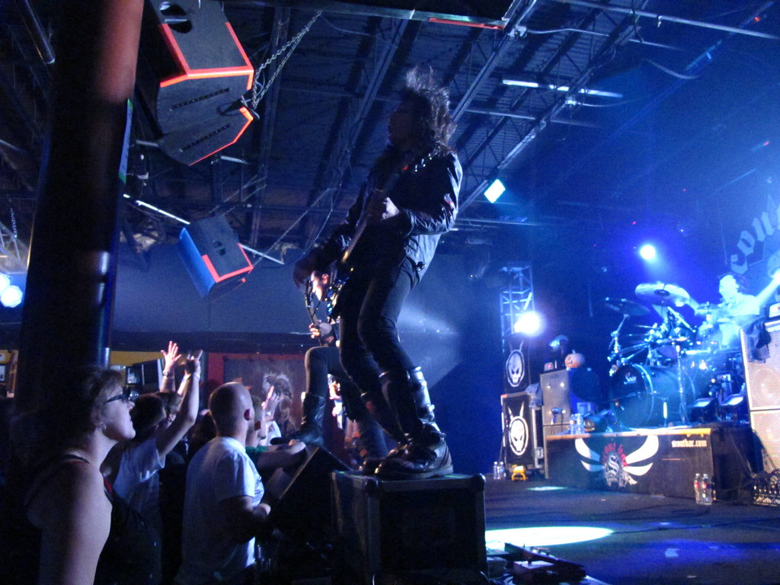

<https://goo.gl/images/qG6rLN>

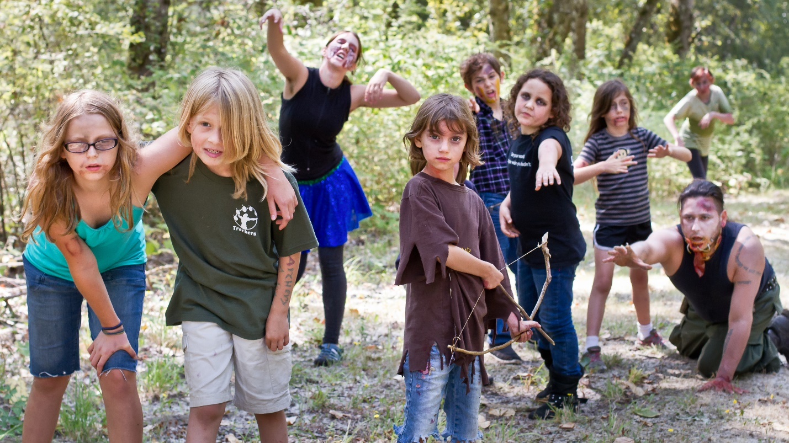https://trackersbay.com/youth/spring-break-camps/zombie-survival.php

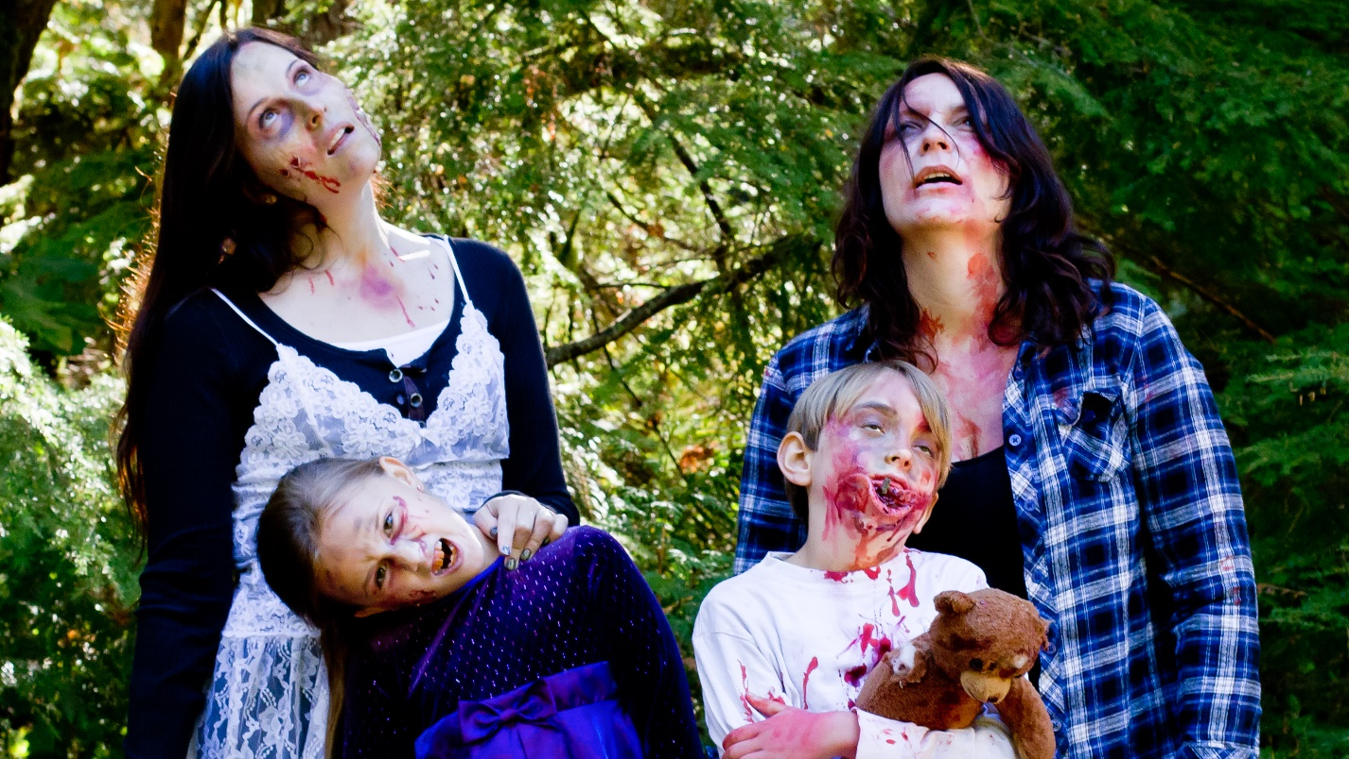

https://trackersbay.com/youth/summer-camp/residential-overnight/zombie-survival-overnight-camp.php

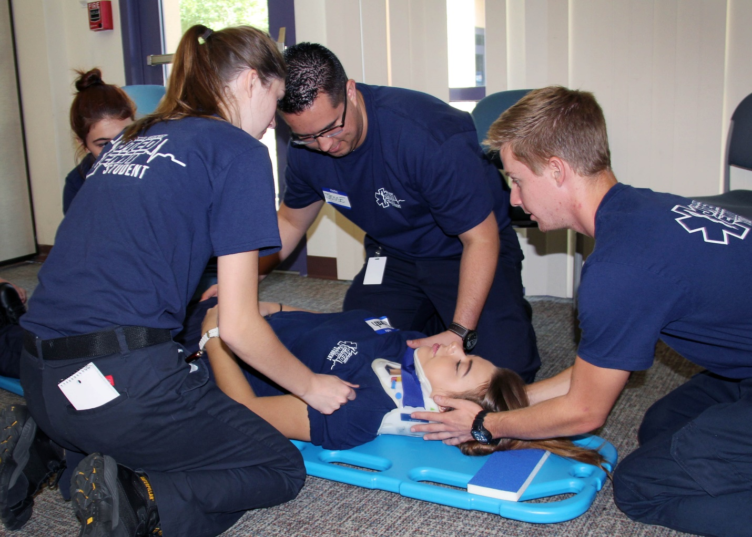https://pimajted.org/2015/12/jted-emt-students-save-lives/

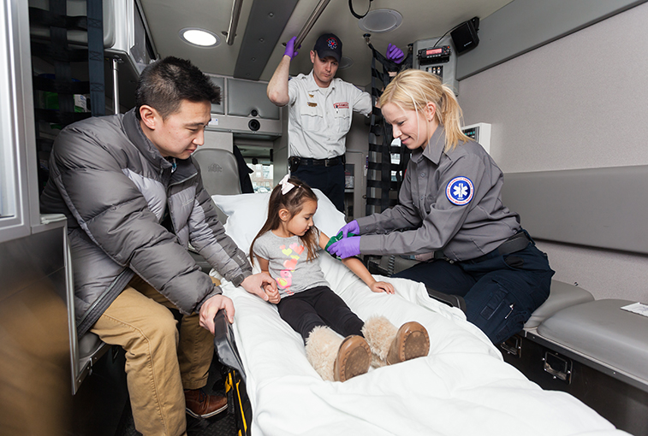

https://news.sanfordhealth.org/emergency-medicine/sanford-health-offers-emt-training/

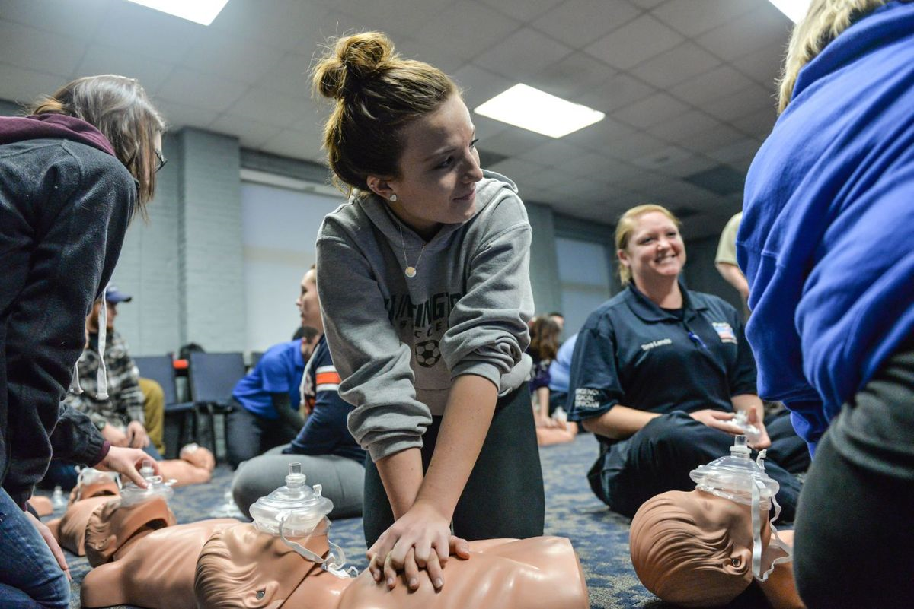

http://www.ccems.org/high-school-students-take-emt-training/

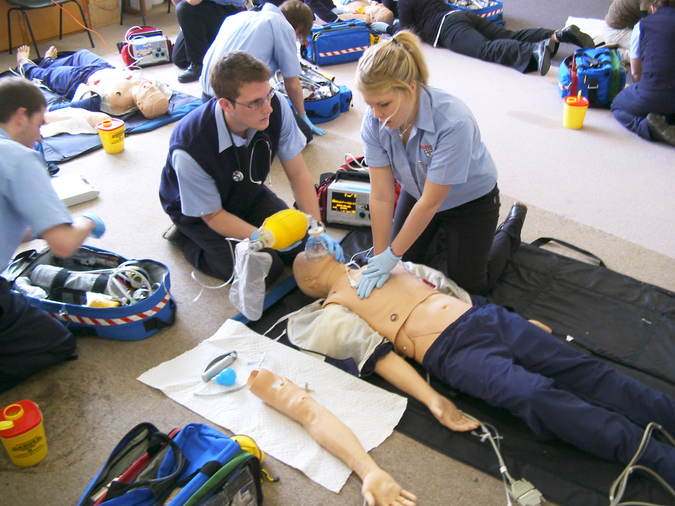

https://www.hci.edu/hci-news-blog/294-courses-to-take-throughout-emt-career

Template Code for Contact Us Form

<https://bootsnipp.com/snippets/featured/contact-form-with-social-network-links>

Code for Responsive Media Player

<https://tympanus.net/Development/AudioPlayer/>



<https://theendivechronicles.com/zombie-banner.html>

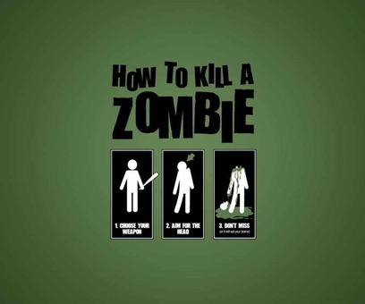

<http://www.fanpop.com/clubs/zombies/images/22245323/title/how-kill-zombie-photo>

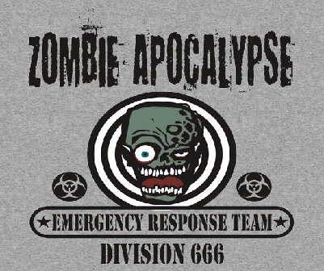

<https://www.redbubble.com/people/davidayala/works/9507972-zombie-emergency-response-team-666?p=womens-fitted-scoop>

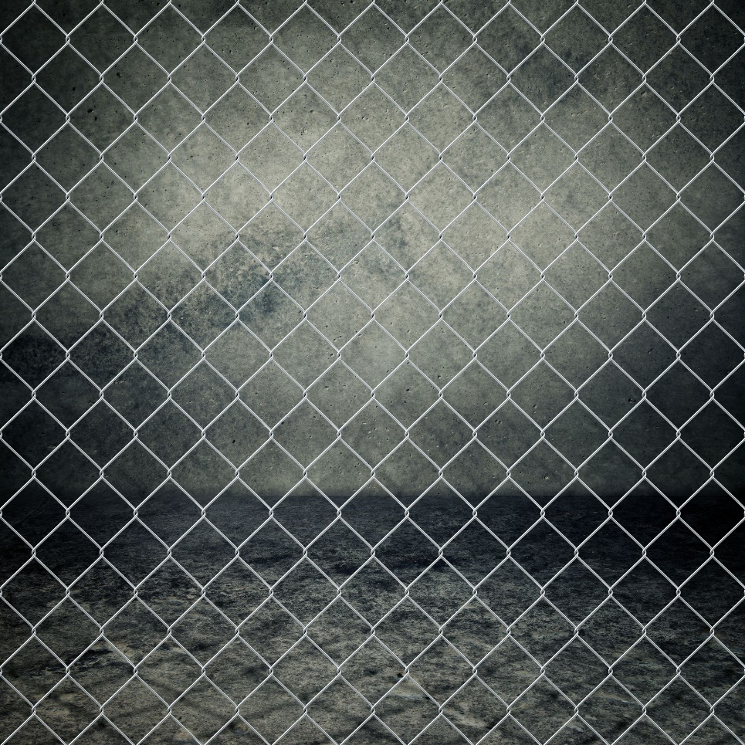

<https://www.shutterstock.com/search/links+in+a+chain?searchterm=links%20in%20a%20chain&search_source=base_related_searches&language=en&page=2&section=1>

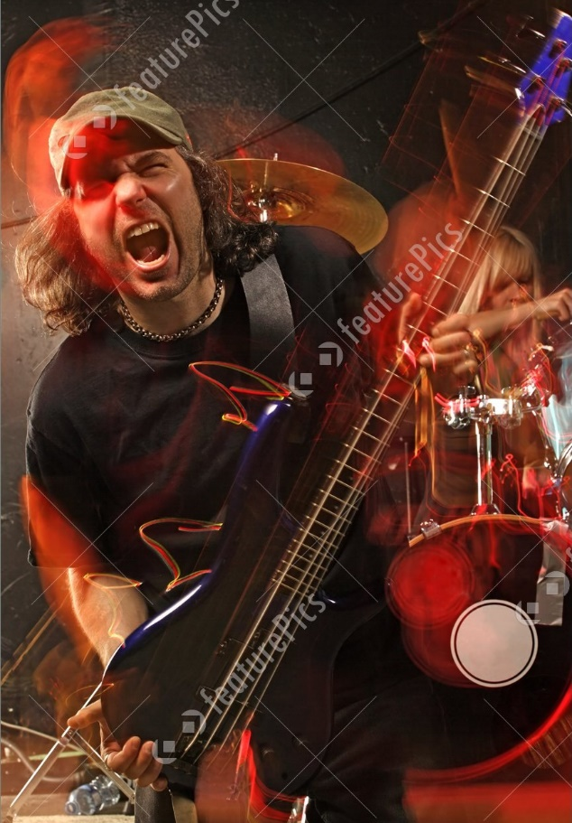

<https://www.dreamstime.com/stock-photos-heavy-metal-bass-guitar-player-image17002033>



<https://www.shutterstock.com/search/chad+kroeger>

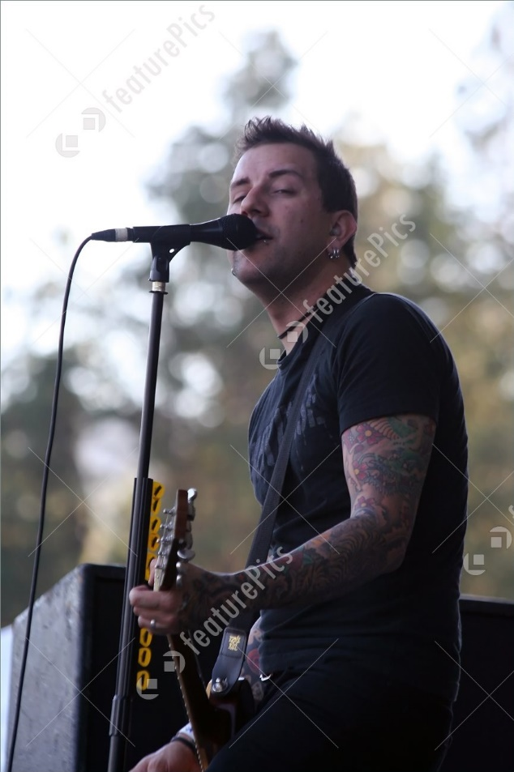

<https://www.shutterstock.com/image-photo/heavy-metal-singer-performing-live-making-1941121>



<https://www.shutterstock.com/image-photo/young-guitarist-playing-guitar-isolated-on-105919595>

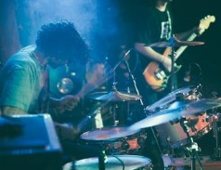

https://burst.shopify.com/photos/live-concert-drums